1)Component Diagram

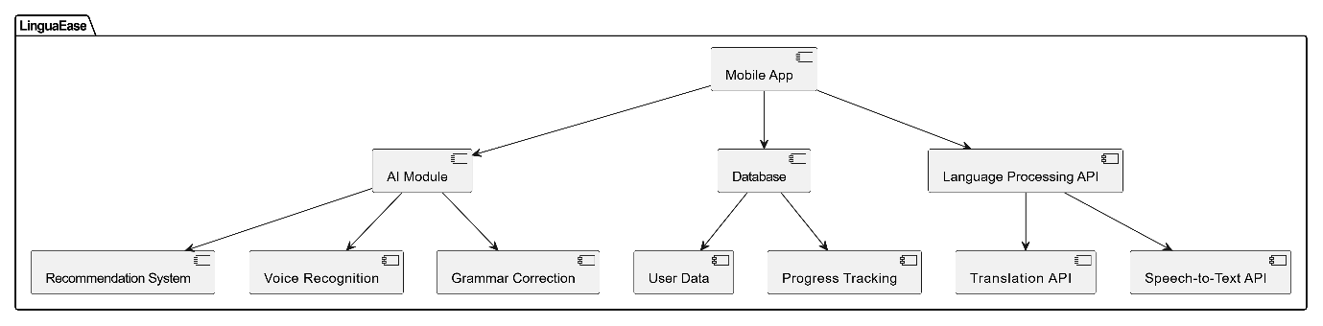

2)Context Diagram

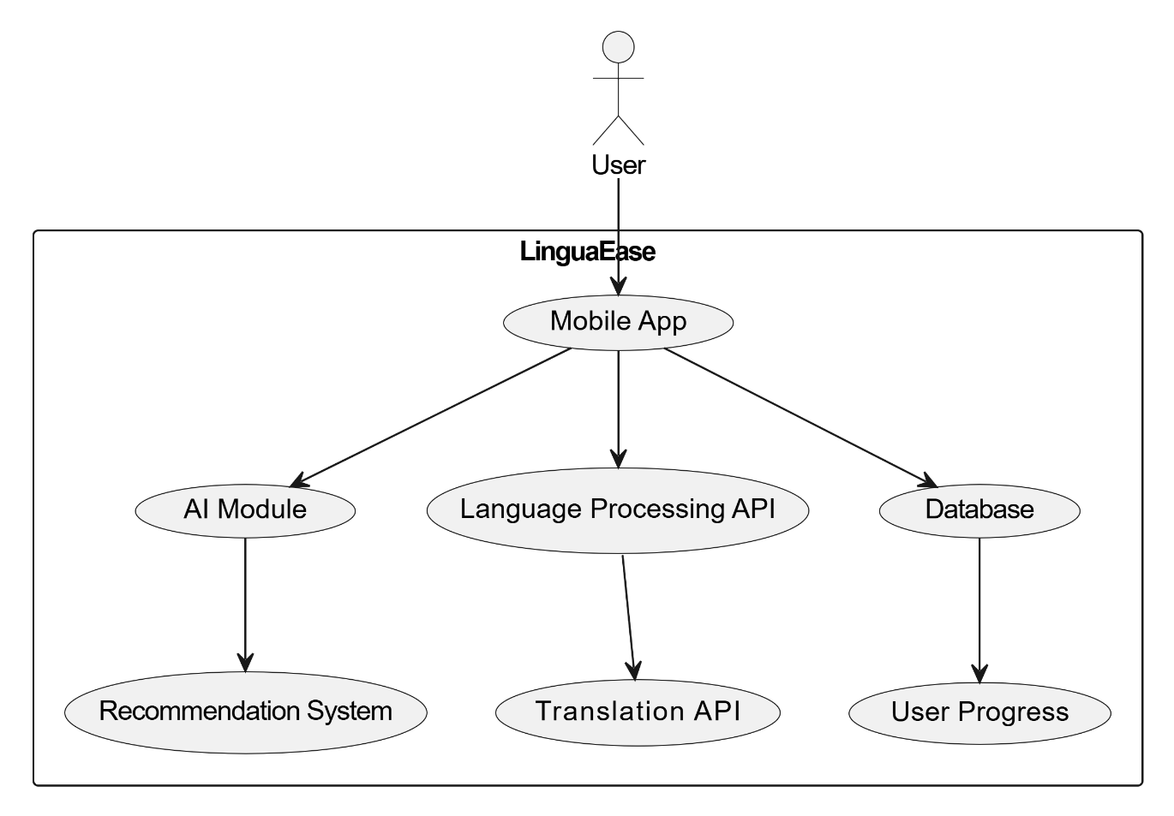

3)Data Flow Diagram

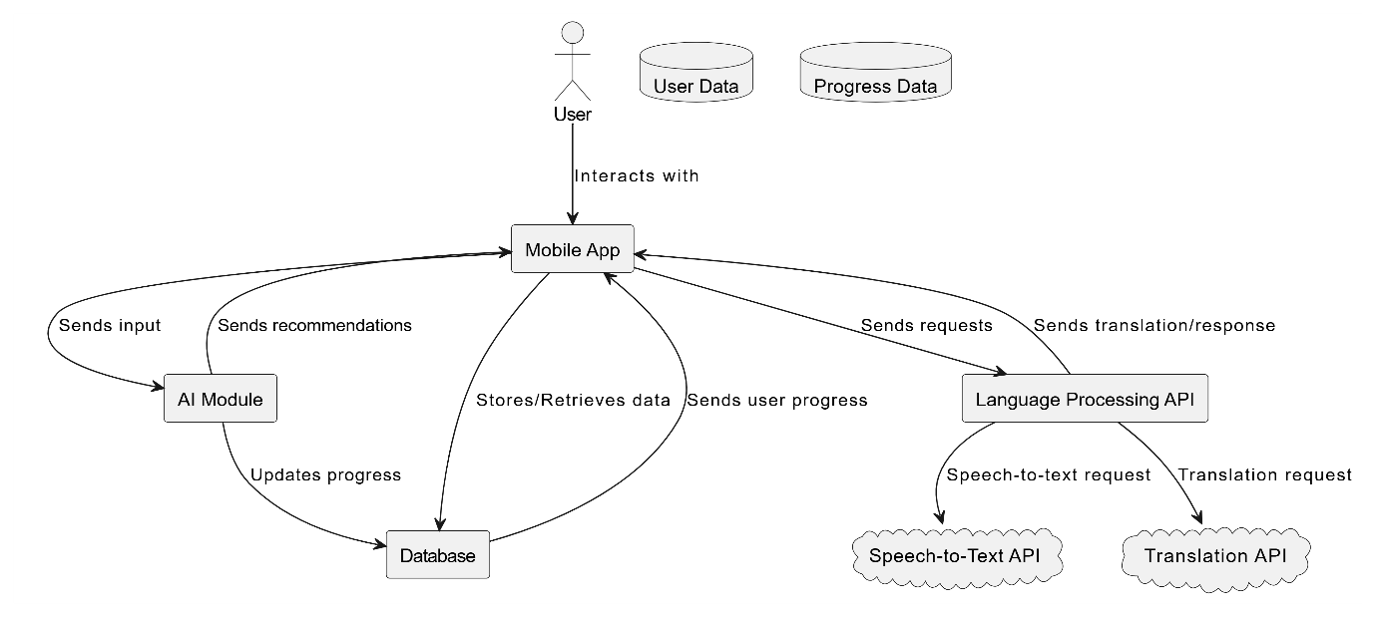

4)Package Diagram

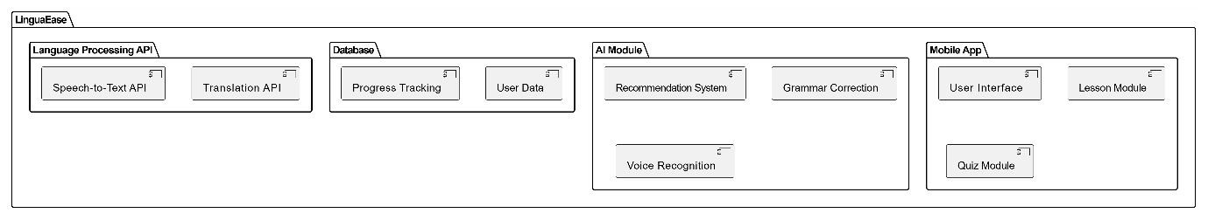

5)Deployment Diagram

